Forest Concession Planning:
Proposed Spatial Organization of PT REKI’s Working Area
Penataan Areal Kerja
(Land Use Planning)
Progress as of July 2025

Prepared by:
Agus B. Utomo, Ola Elveri, Shelin Khusnul Permata

Review or Contribution:
Adam Aziz, Agus Sarsito, Fauzan Syamsuri, Habibi, Rohmat Eko Santoso, Tom A. Walsh

Table of Contents

I. Expected Outcomes 1
II. Challenges 1
III. Opportunities 2
IV. Approach 3
V. Legal Framework 3
VI. Multi-Business Forestry 5
VII. Proposed Land-Use Directions (Arahan Penggunaan Lahan) 6
VIII. Zonation for land-use management 8
A. Protection areas (Kawasan Lindung) 9
B. Production areas (Areal Produksi) 13
IX. Land allocation for forest utilization (land use management – in progress) 16
References, Glossary and Abbreviations 18

Expected Outcomes
The primary outcome of managing PT REKI’s concessions is the long-term conservation of Sumatra's lowland natural forests and their rich biodiversity, which led to the acquisition of the ecosystem restoration concessions in 2008 and 2010 under the Hutan Harapan Partnership. Given the ecological significance of these forests and the critical ecosystem services they provide, their continued conservation within PT REKI’s concession is expected to deliver wide-ranging benefits, for both local communities and the global environmental landscape. Consequently, biodiversity and ecosystem service outcomes are central to shaping effective land-use management strategies, ensuring sustainable resource utilization and long-term ecological resilience.
The economic implications of administering PT REKI's concessions must not be disregarded. Sustainable forest management requires sufficient funding, making revenue generation from forest utilization a vital component. This approach aligns with the multi-business forestry paradigm, which the government is actively promoting in production forests. Accordingly, land-use management strategies within the concessions should focus on enhancing the value of forest and land assets, ensuring both ecological and economic sustainability.
Finally, to keep PT REKI’s concession management relevant to local community issues, connected to the surrounding area, and in line with government goals, it is important to also consider socio-economic results. Supporting indigenous and local communities' access to forest resources is vital to providing social support and land-use stability. Therefore, socio-economic outcomes are an essential element of effective land-use management strategies.

Challenges
Sustainable forest management principles, which encompass economic, social, and environmental aspects, apply to all designated forest areas, including conservation, protection, and production forests in Indonesia. Thus, PT REKI’s forest concessions management is expected to generate a diverse array of benefits—environmental, social, and economic—through its integrated and sustainable management approach.
Revenue generation from forest utilization is a critical pillar of effective sustainable forest management. Therefore, allocating a proportional area of the forest to produce both tangible and intangible products is essential for implementing sustainable forest management within the concessions. Biodiversity and ecosystem services—currently regarded as key elements in strategic planning—should be complemented by social and economic considerations to shape an effective land-use management strategy that ensures the sustainable utilization of forest resources.
The management of PT REKI’s concession has encountered persistent challenges, including encroachment, illegal activities, and financial shortfalls. Management costs have remained high due to the resources needed to address encroachment and other illegal activities. Since the issuance of the forest utilization permit in 2007, financial self-sufficiency has remained a challenge and donor support remains important. Considering these conditions, a clear and decisive shift in management concepts and practices is urgently needed.
PT REKI was granted a utilization permit for the restoration of natural production forests. Restoring degraded production forests to achieve ecological balance is PT REKI’s primary obligation before any measurable harvesting can occur provided the company remains capable of generating income and contributing to economic development at the community, regional, and national levels.
Nevertheless, the critical re-evaluation of the concession area's 60–70% (60,000–70,000 hectares) allocation for conservation purposes is warranted due to the inadequate integration of the economic and social aspects of sustainable forest management. The current management approach has not yet provided the complete range of economic and social benefits that are required for PT REKI to demonstrate its alignment with broader development objectives. In addition, while the markets for carbon and ecosystem services form alluring prospects, these are still uncertain and at least in the medium-term may not be sufficient to service as primary, dependable sources of social and economic value.

Opportunities
Given that biodiversity and ecosystem service outcomes are central to the management of the Hutan Harapan forestry concession, the following represent two key opportunities to consider in developing land-use management strategies as basis for REKI’s concession management.
Nature-based Solutions (NbS) have been mainstreamed through international frameworks and standards that position ecosystem services as viable commercial offerings. At the 5th UN Environment Assembly, NbS were defined as actions to protect, conserve, restore, and sustainably manage ecosystems to address social, economic, and environmental challenges while delivering human well-being and biodiversity benefits. The IUCN pioneered the concept over 20 years ago and today maintains the Global Standard for Nature-Based Solutions, providing eight criteria and 28 indicators that guide both public and private actors in designing investible, high-integrity NbS projects.
Indonesia has codified Nature-based Solutions as a business foundation through recent regulations and institutional initiatives. Government Regulation 23/2021 and Ministerial Regulation 8/2021 formally introduced categories of “environmental service utilization,” which encompass, among others, pemulihan lingkungan (environmental recovery) for ecosystem restoration and biodiversity protection—thereby enabling companies to monetize these outcomes via nature credits or biodiversity credits. This will be further detailed in the legal framework section.
On 21 January 2025, the President of the Republic of Indonesia issued Presidential Regulation 5/2025 on Penertiban Kawasan Hutan (Forest Area Enforcement). This regulation builds on a decade-long effort to formally delineate forest boundaries, confirming 99.6 million hectares of forest and securing 332,184 km of boundary lines—88.88 percent of the total—on paper. By establishing clear legal status, it expected to reduce tenure conflicts and create a stable foundation for managing and valuing forest ecosystem services.
The regulation establishes a dedicated Satgas Penertiban Kawasan Hutan (Forest Area Enforcement Task Force) - directed by the Minister of Defense and operationally led by the Deputy Attorney General for Special Crimes—empowered to reclaim unlawfully used land and impose administrative sanctions. This robust enforcement framework is expected to deter illegal conversion and incentivize compliant, sustainable stewardship of ecosystem services. However, this regulation is new and we need to see how this unfolds in practice. As tenure risks are resolved and governance continues to strengthen, communities, companies, and investors will be increasingly empowered to design and implement Payments for Ecosystem Services (PES) schemes built on carbon, biodiversity, and other high-value ecosystem services.

Approach
Strategies to be discussed
Given the challenges, achieving the diverse objectives of its concession management requires PT REKI to assess the current condition of the forest and its utilization to define the desired future state envisioned through its management efforts.
The existing forest conditions within the concession are shaped by several key factors. Most notably, the forests are secondary forests, having undergone commercial logging, resulting in altered and diverse ecological conditions. Additionally, extensive non-forested areas within the concession are used for various non-forest purposes by different groups. Some of these land uses have made forest restoration very difficult, even after successful reclaim, as they have caused complete deforestation and converted once-forested land into degraded, unproductive areas. Furthermore, in certain parts of the concession, forest and land utilization is restricted or entirely unfeasible at this time due to illegal occupation by third parties.
Given the diverse land utilization by various groups, land-use strategies for PT REKI’s concession should adhere to an effective management approach. Priority should be given to areas that can be efficiently managed, either independently or through partnerships and collaborations with other stakeholders. Conversely, ineffective areas—those rendered currently unmanageable due to ongoing land conflicts—require a dedicated conflict management plan, as mandated by government regulations.
Due to the heterogeneous nature of secondary forests and diverse land-use practices as well as the multiple management objectives, forest landscape restoration presents a viable approach. Land-use management strategies should integrate objectives that restore multiple functions for multiple benefits while maintaining and enhancing natural forest ecosystems within the concessions. With this approach, Nature-based Solutions can be developed as a business foundation for PT REKI’s concessions.
The forest landscape restoration approach also aligns with the Multi-Business Forestry paradigm, which the government is actively promoting in production forests utilization. Accordingly, land-use management strategies within the concessions should focus on enhancing the value of forest and land assets, ensuring ecological, social and economic sustainability.

Legal Framework
The forest category under which PT REKI’s concession license was granted is classified as a production forest area (hutan produksi). According to Forestry Law 41/1999 (Undang-Undang Kehutanan), production forest areas are one of the three main classifications of forest function, alongside protection forests (hutan lindung) and conservation forests (hutan konservasi). Production forests are designated for the purpose of producing forest products as well as environmental services.
PT REKI holds two ecosystem restoration concessions (ERCs) granted in 2007 and 2010, respectively. These concessions represent a new category of forest utilization permits, with ecological restoration as the primary objective. Various forms of forest utilization for non-timber forest products and environmental services are permitted, whereas timber harvesting is explicitly prohibited during the restoration phase. Timber utilization may be permitted once ecological equilibrium is achieved, subject to the necessary adjustment of licenses from ecosystem restoration to timber utilization. These were specified in the Government Regulations 6/2007 and 3/2008.
However, the government regulations were changed in 2021 following the enactment of Omnibus Law. Currently, it is the Government Regulation (PP) 23/2021 on the Implementation of Forestry that forms the basis of planning for PT REKI. This has been followed by the Minister of Environment and Forestry Regulation (PermenLHK) 8/2021 on Forest Planning and the Preparation of Forest Management Plans as well as Forest Utilization in Protection and Production Forests.
Based on these new regulations, PT REKI’s licenses were transformed from ERCs into Forest Utilization Business Permits for Environmental Services (PBPH Jasa Lingkungan) in 2021. While this explicitly authorizes PT REKI to develop various enterprises based on the utilization of environmental services, the term 'ecosystem restoration' has been redefined as 'environmental recovery' (pemulihan lingkungan), which is now categorized as one of the permitted forms of environmental service utilization. Accordingly, environmental recovery (pemulihan lingkungan) now constitutes the primary category of forest utilization within PT REKI’s concessions.
According to PP 23/ 2021, environmental recovery as a category of forest utilization in production forest shall be carried out through the maintenance, protection, and restoration of forest ecosystems, including planting, enrichment, thinning, wildlife breeding, and the release/reintroduction of flora and fauna. These efforts aim to restore both biotic components (flora and fauna) and abiotic components (soil, climate, and topography) within a given area to their native state, thereby achieving biological and ecosystem balance.
Further, the environmental recovery activities aim to enhance productivity and biodiversity, improve forest stand structure, and protect forest ecosystems. Prioritization is determined based on-site potential and the degree of degradation, and implementation follows these stages: (a) nursery establishment/seedling production; (b) planting/enrichment; (c) maintenance; (d) habitat restoration for flora and/or fauna; (e) protection and safeguarding; and (f) research and development. This implies that environmental recovery as a category of forest utilization is to enhance natural forest ecosystems.
Further, in 2022, the Minister of Environment and Forestry issued Circular Letter SE.6/MENLHK/SETJEN/PLA.4/12/2022 concerning the Approval of Forest Utilization Business Work Plans for Multi-Business Forestry Enterprises. The letter formally encourages license holders within production forest areas to adopt a multi-business forestry approach in the planning and management of their concessions. For PT REKI, this implies that business development based on non-timber forest products and other environmental services is no longer discretionary—it has become a regulatory expectation.
In May 2025, the Director General of Sustainable Production Forest Management formally requested PT REKI to accelerate the revision of its long-term management plans (10-year plans for Jambi and South Sumatra concessions) to reflect the aforementioned changes, primarily: the conversion from Ecosystem Restoration Concession (IUPHHK-RE) into Forest Utilization Business Permits for Environmental Services and the adoption of the multi-business forestry approach.

Multi-Business Forestry
Forest landscape restoration as an approach aligns closely with the Multi-Business Forestry (Multi Usaha Kehutanan) paradigm, which PT REKI, as the holder of Forest Utilization Business Permits for Environmental Services (PBPH Jasa Lingkungan), is required to implement.
The paradigm of ‘Multi Usaha Kehutanan’ is promoting the following, among others:
- Stronger emphasis on the use of forest resources and forest areas to carry out multiple forestry businesses based on forest products and/or environmental services. As noted, this is different from the ERC framework where utilization for business development was optional.
- Stronger emphasis on productive forest management
- Maintaining the existing forest cover but utilizing non-forested areas for productive activities.
- Working area arrangement (land-use) should reflect the intended utilization of the forest within the effective area.
- Conflict areas must be mapped, and a conflict management plan should be made available and implemented.
As a result of implementing the multi-business forestry paradigm, an improved land-use planning should form the foundation of PT REKI’s concession management, ensuring that forest utilization aligns with the diverse models applied across its two concession units. In terms of policy implication, the following are important to be considered:
- The description of what was formerly classified as an ERC is now embedded within the environmental services business category known as Environmental Recovery. This shift in nomenclature does not alter the scope of the licenses held by PT REKI.
- Development of other business categories under the utilization of other environmental services and non-timber forest products is no longer optional. It is now mandatory to implement multi-business forestry. This includes reclassification of the forest utilization already approved by government in the current long-term management plans (RKU).
Decision to be taken
Considering the above policy implications to PT REKI’s concession management, the following utilization categories are currently applicable for PT REKI in terms of developing a diversified businesses to be agreed and approved:
- Environmental Service Utilization – Environmental Recovery (Pemulihan Lingkungan). This is due to the original licenses of PT REKI being for ecosystem restoration. The scope of the ERC licenses is now embedded into this category of environmental service utilization. All restoration activities will be included under this business category of forest utilization.
- Environmental Service Utilization – Biodiversity Protection (Perlindungan Keanekaragaman Hayati). PT REKI has implemented targeted conservation initiatives for key species, including monitoring of the Sumatran elephant and Sumatran tiger as part of ecosystem restoration activities in its RKUs. This category of environmental service utilization was newly introduced under Government Regulation 23/2021 and Ministerial Regulation 8/2021, with its implementation governed by the Law on the Conservation of Living Natural Resources and Their Ecosystems. This category opens the possibility of monetizing biodiversity outcomes, such as nature credits or biodiversity credits.
- Environmental Service Utilization – Carbon Storage and Sequestration (Penyerapan dan Penyimpanan Karbon). PT REKI has already stated its plan to develop a carbon project in its RKUs approved by the then Ministry of Environment and Forestry. This category opens the possibility to generate carbon credits.
- Environmental Service Utilization – Nature Tourism: ecotourism special interest and [lodging] (Wisata Minat Khusus dan [Tempat Peristirahatan]. PT REKI has already stated its plan to work on ecotourism in the current RKUs approved by the then Ministry of Environment and Forestry. In addition to developing special interest tourism such as birding and cultural experience, PT REKI needs to consider including current lodging facilities to be reported as part of this category if it will be expected to generate revenue.
- Utilization of Non-Timber Forest Products (NTFPs) (Pemanfaatan Hasil Hutan Bukan Kayu). There have been several trials and efforts to cultivate some of the areas in PT REKI to produce NTFPs. Therefore, these need to be planned properly and laid out in the plans submitted to the government. This category of forest utilization has also been approved by the then Ministry of Environment and Forestry.
- Forest Area Utilization – Agroforestry and [Silvopasture] (Wana Tani & Wana Ternak). PT REKI has engaged with community groups through the social forestry scheme (Forestry Partnership), supporting initiatives such as rubber agroforestry and the introduction of cattle breeding. This category of forest utilization was approved by the then Ministry of Environment and Forestry as part of the concession partnership with local communities. The existing silvopasture practices, initially implemented as part of community development, should now be transitioned into a formal business partnership model
- Forest Area Utilization – Cultivation of Fruits and Seeds (Budidaya Buah-buahan dan Biji-bijian). PT REKI is piloting the cultivation of vanilla in shade houses and under the canopy of secondary forests, which falls under this business category. Alternatively, enrichment of secondary forests for NTFP production can also be registered under utilization of NTFPs (see No. 5 above). In the current RKU, vanilla was considered as a NTFP utilization sub-category, that is vanilla agroforestry. In the new RKU, vanilla in the shade house will be classified as part of forest area utilization, whereas the vanilla under the canopy will be classified as NTFP utilization.

-----

Proposed Land-Use Directions (Arahan Penggunaan Lahan)
In the two forestry concessions of PT REKI, the multiple forest businesses can be developed using three possible approaches: Business Diversification (Diversifikasi Usaha); Forestry Partnership (Kemitraan Kehutanan) and Food and Energy Resilience (Ketahanan Pangan dan Energi). These approaches are following the guidelines provided by the Ministry of Forestry (formerly Ministry of Environment and Forestry). The first approach can be implemented in effective areas free from conflict or illegal occupation. The second and third approaches can be models for utilizing forest areas that are in conflict or prone to conflict and areas that are under agreement with communities.
The plan for Multi Usaha Kehutanan should be made available before preparing revised RKUs. After deciding the categories of forest utilization businesses to be developed, the first step is to develop a working area arrangement (Penataan Areal Kerja) which is a broad land use allocation. Such a consolidated working area arrangement should be prepared to reflect the intended forest utilizations to be developed in the next 10 years. However, the original forestry license (e.g. ecosystem restoration for PT REKI), should determine the dominant forest utilization to be developed (e.g. Environmental Service Utilization).
Strategies to be discussed
Before establishing the working area arrangement, it is essential to formulate strategies or directions for land-use allocation. The following outlines key strategies for developing land-use allocation within PT REKI’s concessions:
- Forestry businesses are to be developed in suitable areas within both Protection Areas (Kawasan Lindung) and Production Areas (Area Budidaya) that are free from illegal occupation and thus available for planned utilization (effective areas).
- The core forest block will be the main target area for the development of environmental service utilization businesses and will form the main part of the Protection Area (used to be called Protection Zone). Additional areas will be identified as part of environmental recovery.
- Degraded lands within effective areas, including reclaimed sites and senescent acacia stands, will undergo rehabilitation through natural regeneration, mixed planting of selected multi-purpose tree species, employing cost-effective silvicultural techniques to be developed. Therefore, both NTFP cultivation in Production Areas and ecological rehabilitation in Protection Areas will be part of environmental recovery.
- Small areas will be allocated for intensive cultivation of non-tree species in controlled environments such as shade houses located in degraded areas.
- Low secondary forests, primarily within Production Areas, will be designated for enrichment with high-value understory NTFP species such as vanilla and others.
- In areas under community management, agroforestry will continue to be used to utilize forest area to produce NTPFs as well as other benefits.
- In conflict areas where efforts are underway to resolve land occupation, utilization of the deforested areas will depend on the results of negotiations or when feasible the land is reclaimed.
- In conflict areas where resolution efforts have been unsuccessful, these Challenged Areas will be prioritized for collaboration with local governments to facilitate government-led programs including forest area enforcement.
Map 1 on page 8 illustrates the classification of PT REKI’s concessions into three categories: Core Forest Block, Cultivation/Rehabilitation Areas, and Challenged Areas, consistent with the key strategies outlined above. These land-use classifications are informed by current land utilization and forest/land cover conditions. The Core Forest Block of about 70,194 ha encompasses the main expanse of existing natural forest within the concessions. Cultivation/Rehabilitation Areas of about 10,599 ha include fragmented forest patches, sites reclaimed from illegal occupation, zones under co-management with community groups, recently occupied areas under negotiation or undergoing reclamation, and senescent acacia stands slated for restoration. Challenged Areas totalling about 17,216 ha refer to illegally occupied zones where resolution efforts have encountered persistent difficulties, and which remain subject to forest area enforcement by the government.
-----

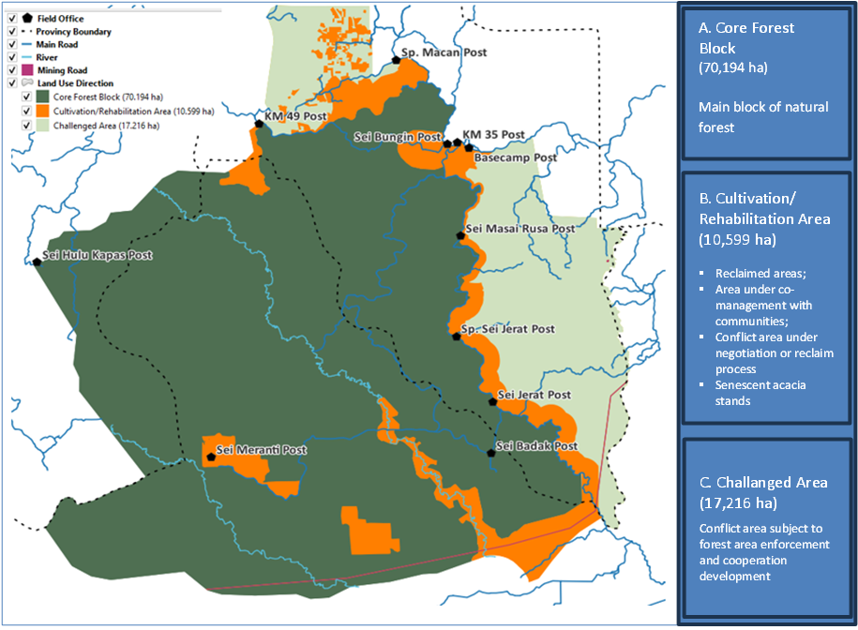
B
B
C
B
A
A
B
Map 1. Land-use management directions

Zonation for land-use management
The working area arrangement for managing forestry concessions in Indonesia can be broadly categorized into two interrelated functions: first, the working arrangement for forest management and utilization (land-use management); and second, the working arrangement for area management. The following table is to describe the two types of working area arrangements.

Table 1. Type of working area arrangement being prepared for PT REKI’s concessions
Purpose | Function | Type of planning activity
Forest management and utilization (land-use management) | For the planning, regulation, and supervision of forest and land utilization. | Delineation of utilization plans through designated land-use directions, zoning of work areas, and allocation of utilization areas.
Area management | For territorial control, regional planning, and organizational management. | Structured through the division of management units, work blocks, and work plots.

The forest management and utilization plan for PT REKI’s concessions aims to guide land-use strategies, ensuring that forest and land resources are more effectively allocated to achieve sustainable forest management. The previously outlined land-use directions will inform the zoning and allocation of forest areas for various business purposes.
As described earlier, PT REKI currently holds two Forest Utilization Business Permits for Environmental Services (PBPH Jasa Lingkungan) issued by the Minister of Environment and Forestry (KLHK) in 2021, as the transformation of the two previous Timber Forest Product Utilization Permits – Ecosystem Restoration (IUPHHK-RE) granted by the Minister of Forestry in 2007 and 2010. Both business permits held by PT REKI are classified as PBPH for Environmental Service Utilization, due to their original permits being IUPHHK-RE.
Furthermore, as the initial permits and approved Environmental Impact Assessment (AMDAL) were issued for forest restoration, the predominant category of environmental service utilization in PT REKI’s concessions will be Environmental Recovery. However, within the multi-business forestry framework, PT REKI should also explore additional environmental service opportunities, such as carbon storage and sequestration, biodiversity protection, and ecotourism to form the business foundation of Nature-based Solutions. In addition, forestry businesses based on the utilization of non-timber forest products and forest areas should also be integrated.
A simplified zoning framework has been established to guide future land-use planning, based on current land utilization, forest cover, and planned forest utilization within PT REKI's concessions, in accordance with government requirements. The zonation divided the concession areas into protection areas (Kawasan lindung) and production areas (areal produksi).

Protection areas (Kawasan Lindung)

A.1. Identification of protection areas
Strategies to be discussed
To maximize the utilization of environmental services for Nature-based Solutions businesses, PT REKI must preserve and manage its natural assets, including natural forests and biodiversity within its two concession areas. Considering these factors, PT REKI has designated a significant portion of its two concession areas as protection areas to support natural forest and biodiversity conservation, ensuring a strong foundation for developing environmental service initiatives.
Although environmental service utilization can also be implemented in production areas (cultivation areas), PT REKI has decided to prioritize its development in protection areas based on several strategic considerations.
First, in line with government regulations on work area arrangement, PT REKI’s protection areas serve as germplasm conservation zones and wildlife protection areas. Aligning these conservation objectives will enhance the effectiveness of environmental service management and utilization.
Second, the lowland tropical forests within PT REKI’s concession provide a natural habitat for various protected and globally endangered species. By incorporating all areas with natural forest cover into protected zones, the conservation and utilization of lowland tropical forests and their biodiversity can be optimized.
In line with the land-use directions, protection areas within PT REKI’s concessions are designated to correspond with core forest block. Their management prioritizes the preservation of natural forests, biodiversity conservation and sustainable use of environmental services in ways that maintain landscape integrity and natural forest cover. The core forest block previously identified constitutes the principal component of these protection areas and is actively managed to prevent fragmentation. As such, these areas reflect the company’s commitment and credibility in safeguarding compact, unfragmented natural forests. In addition, the protection areas also encompass degraded lands and forests within or adjacent to the core forest block, which are designated for ecological rehabilitation to enhance the integrity of the core forest.
-----
To further delineate the protection areas, their designation within PT REKI’s concessions is primarily guided by government-defined criteria, complemented by internally developed standards that integrate various operational considerations.
The main government’s criteria based on Ministerial Regulation 8/2021 being used are the following.
  - The third criterion pertains to the riparian areas of rivers and lakes:
- Areas within 500 meters of the lakeshore
- Areas within 100 meters on both sides of the riverbank
- Areas within 50 meters on both sides of the creek's edge
  - The fifth criterion for the buffer zone surrounding the main natural forest block.
  - The sixth criterion for germplasm conservation areas (Kawasan Pelestarian Plasma Nutfah - KPPN) and wildlife protection areas.
  - Areas designated for the implementation of multi-business forestry, focusing on the utilization of environmental services.
Considering the land-use management directions and the operational requirements, the following criteria are established to guide further the delineation of protection areas within the two concessions of PT REKI. The numbering in brackets correlate with the four mandated criteria described above.
- The area is primarily composed of connected natural forests, with limited open spaces that do not lead to fragmentation (3).
- Critical habitats for protected and globally endangered species (3).
- Areas with potential for environmental service utilization (4).
- Areas to be managed for environmental recovery, focusing on the ecological restoration and/or rehabilitation of natural forests (2).
All the above areas should also meet additional criteria: e) un-affected by illegal land occupation (2,3,4); and f) the concession management unit has a sufficient level of confidence in its ability to maintain the integrity of the natural forest within the designated protection areas (2,3,4).
- Previously occupied areas that have been reclaimed or are undergoing repossession, intended to be rehabilitated for habitat expansion or ecological buffering (2).
- Additional riparian areas of rivers and lakes beyond the previously mentioned areas, where PT REKI has outlined its commitment in environmental management documents (1).
Based on the above criteria, 73,689 hectares of PT REKI’s concessions have been designated as protection areas. The following table provides details on the identified areas, which are visualized in Map 2 on page 12.
Table 2. Identified protection areas in PT REKI’s concessions
Identified Protection Areas | Area (Ha)
- The main block of natural forest (a), including the riparian areas (b) within (c)  - The germplasm conservation areas (Kawasan Pelestarian Plasma Nutfah - KPPN) and wildlife protection areas.  Forests  Shrubs, non-forest and water bodies  - Riparian areas  Forests  Shrubs, non-forest and water bodies | 68,785  65,145  60,852  4,293  3,659  3,377  262
- The natural forest area in the southern part (South Sumatra unit) - divided by the PPKH permit for mining road development (b), (c)  - The germplasm conservation areas (Kawasan Pelestarian Plasma Nutfah - KPPN) and wildlife protection areas.  Forests  Shrubs, non-Forest and water bodies  - Riparian areas  Forests  Shrubs, agriculture, non-forest, water bodies | 1,222  1,177  1,075  102  45  25  20
- Senescent acacia stands within the main block of natural forest – to be rehabilitated (d) | 1,670
- Areas being reclaimed for buffer – (area km 52) (g)  - Buffer Area  Shrubs  Agriculture, non-forest, water bodies  - Riparian areas | 556  527  154  373  29
- Riparian areas beyond the main block of natural forest and other identified areas, delineated by river and lake boundaries (h).  - Lakes  - Riparian areas  Forests  Non-forests, agriculture, scrub, water bodies | 1,426  10  1,416  149  267
Total PT REKI’s Protection Areas | 73,689

Decision to be taken
As shown in the above table, the protection areas of Hutan Harapan forestry concessions composed of: A) the main block of natural forest (65,145 ha); B) fragmented natural forest due to coal mining road (1,222 ha); C) senescent acacia stands within the main block of natural forest to be rehabilitated (1,670 ha); D) areas being reclaimed for buffer (556); E) riparian areas beyond the main block of natural forest and other areas (1,426 ha).
-----
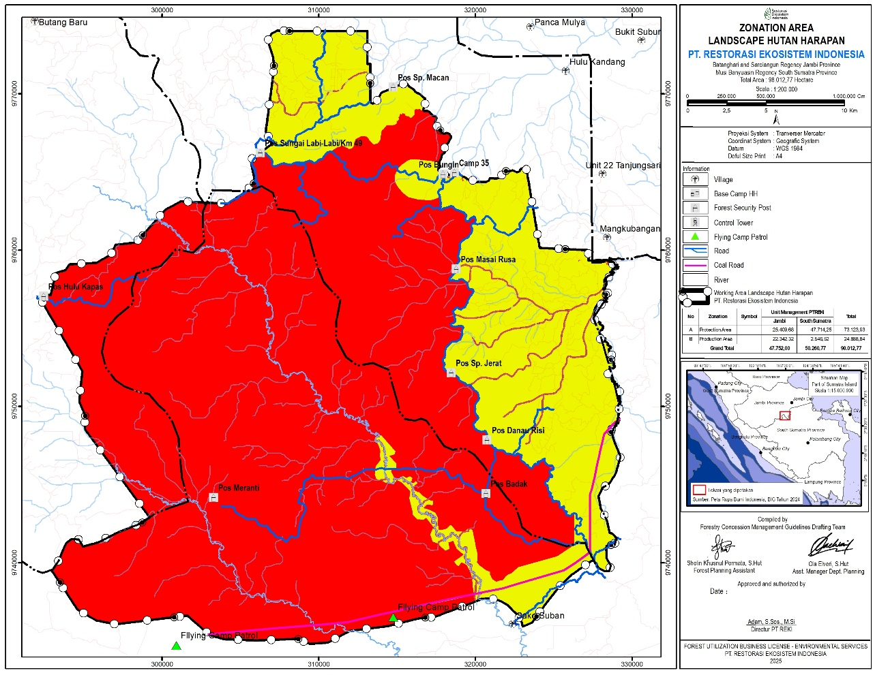
- Production Areas
24,325 ha

- Protection Areas
73,689 ha

A
B

Map 2. Identified protection and production areas in PT REKI’s concession

A.2. Management of the protection areas
Strategies to be discussed
To manage the protection areas, programs and activities will be systematically arranged as part of forest management plan to be developed in parallel with land-use planning process. The following are the key strategies to be reflected in the management plan in relation to the protection areas of PT REKI’s concessions.

- Forest protection
The primary goal of forest protection in designated protection areas is to preserve the integrity of the core forest block and its buffer zones. Specifically, protection measures aim to eliminate illegal land occupation, prevent and combat forest fires, and halt illegal logging, mining, poaching, and encroachment. Targeted efforts will be strategically planned and implemented in areas most vulnerable to such disturbances. Identification of such areas will be described in operational plans.
- Sustainable utilization of environmental services
The following categories of environmental service utilization will be developed within the protection areas of PT REKI’s concessions:
- Environmental recovery
- Biodiversity protection
- Carbon storage and sequestration
- Ecotourism
Designated areas for these functions may overlap within the protection zones. The delineation of each utilization category will be undertaken as part of the detailed work arrangement process. The resulting zonation will form the basis for developing the forest utilization plan under the long-term management strategy (10-year plan).
- Sustainable collection of non-timber forest products
Within the identified protection areas, a cooperation agreement is already in place with a village community in the western part of the Jambi concession unit for the collection of non-timber forest products. Consequently, this utilization category will be further detailed in the long-term management plan.
-----

Production areas (Areal Produksi)

B.1. Identification of production areas
Strategies to be discussed
In addition to protection areas, PT REKI should designate zones for production purposes, where various utilization categories beyond environmental services can be developed. However, timber utilization and extraction remain prohibited, as the approved Environmental Impact Analysis does not include timber-related activities, which formed the basis for PT REKI’s licenses granted in 2007 and 2010. Thus, to develop timber-related activities in the future, the current license will need to be changed to reflect this activity.
As previously outlined under legal framework, the permitted utilization within PT REKI’s production areas includes the extraction of diverse categories of NTFPs, the collection of various NTFPs, and the use of forest land for cultivation and other productive activities. To complement environmental service utilization in protection areas, additional zones will be designated within production areas, particularly in cultivation areas, where environmental recovery can be integrated with NTFPs cultivation and the preservation of remaining fragmented forest patches is still viable.
Considering the above, production areas within PT REKI’s concession allow for controlled modification of natural ecosystems (sustainable management) as part of the transition toward more productive land uses that support ecological, economic, and social functions. The designation of the production areas is primarily based on government-established criteria, supplemented by internally developed guidelines that incorporate various considerations.
The primary criteria for identifying production areas are based on Ministerial Regulation 8/2021, which encompasses both forested and non-forested zones. Article 141(2) outlines the following conditions:
- Non-forested or non-productive areas that are suitable for cultivation.
- Natural forest areas with forest resources that can be utilized by forestry multi-enterprises through area utilization and NTFP extraction.
Additionally, Paragraph 145 of the regulation considers areas with specific social conditions that support the construction and/or development of facilities and infrastructure.
-----
For operational purposes, the following effective areas both forested and non-forested will also be included as production areas:
- Collaborative areas already developed:
  - Areas that have been managed by the community through Concession Partnerships
  - Areas that have been managed under business cooperation agreements
However, the following challenged areas within PT REKI’s concessions should also be included:
- Areas that have been occupied illegally by communities, but forest area enforcement will take place and collaboration with stakeholders will be promoted.
Based on the above criteria, 24,324 hectares of PT REKI’s concessions have been designated as production areas. The following table provides details on the identified areas, which are visualized in Map 2 on page 11.
Table 3. Identified production areas in PT REKI’s concessions
Identified Areas | Area (Ha)
- Areas potential for business development to buffer the main protection area (cultivation area and partly challenged area)  - Development of NTPF businesses integrated with environmental recovery  Forested  Non-forested  Agriculture  Scrub & water bodies  - Area for facilities and infrastructure | 6,844  6,840  949  2,410  2,700  780  4
- Areas that have been managed by the communities (social forestry) for agroforestry and agro-silvo-pasture  - Forestry Partnership  Forested  Non-forested  Agriculture  Scrub & water bodies | 2,448  2,448  963  656  674  155
- Challenged areas illegally occupied by other parties  - Conflict Areas (planned for forest area enforcement and collaboration)  Forested  Plantation  Non-forest  Agriculture  Scrub & water bodies | 14,664  14,824  1,176  2  5,420  7,827  399
- Areas designated by the government for Forest Area Borrowing schemes (PPKH)  - PT MBJ Coal Mining Road Area  Forested  Non-forested  Agriculture  Scrub & water bodies  - SKK Migas JINDI Area (oil and gas) | 208  205  124  40  24  16  4
Total PT REKI’s Production Area | 24,325

Decisions to be taken
As shown in the above table and Map 2 on page 11, the production areas of Hutan Harapan’s forestry concession composed of: A) areas potential for NTFP business development integrated with environmental recovery (6,844 ha) which delineated based on the designated cultivation area in the land-use direction added with part of the challenged area to form a buffer for the protection area; B) areas under forestry partnership with community groups (2,448 ha); C) challenged areas where forest area enforcement is expected to take place; D) areas designated by the government for Forest Area Borrowing schemes (coal road, oil and gas - 205 ha).
-----

B.2. Management of production areas
Strategies to be discussed
To manage the production areas, programs and activities will be systematically arranged as part of forest management plan to be developed in parallel with land-use planning process. The following are the key strategies to be reflected in the management plan in relation to the production areas of PT REKI’s concessions.
- Land-use stabilization
Cultivation areas include patches of natural forest and recently occupied areas. To ensure effective management, the occupied areas must be made available for use, and existing fragmented forest patches should be secured and integrated into the broader land-use strategy. Thus, reclaim and/or negotiation should immediately be carried out in these areas.
Leveraging the opportunity presented by government-led forest area enforcement, illegally occupied challenged areas should be reclaimed. Immediate rehabilitation efforts should be initiated as part of their transition toward productive use, helping to prevent reoccupation and reinforce long-term land stewardship.
- Sustainable utilization of non-timber forest products
In secured areas, particularly those lacking forest cover, the cultivation of plant species including multi-purpose tree species for NTFPs production should be planned and implemented in tandem with rehabilitation efforts. Cost-efficient silvicultural methods must be developed, drawing on available best practices in soil improvement, water management, planting and regeneration techniques, and species selection. In addition to multi-purpose tree species, other non-wood plant species may also be integrated to NTFPs at scale. For example, ginger species can be cultivated to enhance ground cover while contributing to productive yields.
In addition, the production of Non-Timber Forest Products (NTFPs) can be enhanced through enrichment planting in low secondary forests where sufficient sunlight still allows for cultivation.
- Sustainable utilization of forest areas
Areas under co-management with community groups through forestry partnerships are to be integrated as part of multi-business forestry under category of forest area utilization, specifically for agroforest, agro-silvo-pasture, and other agroforestry systems.
In addition, the existing shade house for the cultivation of vanilla should also be categorized under this forest utilization.
- Sustainable collection of non-timber forest products
Harvesting of non-timber forest products from the wild by communities should also be integrated into the multi-business forestry. Current products include honey and damar.
- Partnerships and collaborations
To develop the different forest utilization businesses in production areas, PT REKI can form concession partnerships with communities or business cooperation with other business entities.
-----

Land allocation for forest utilization (land use management – in progress)
Strategies to be discussed
Following the zonation of the concession areas, land allocation (Penataan Areal Kerja) for each planned forest utilization is currently being prepared. In alignment with new regulations, the allocation will reflect the designated forest utilization categories, forming the basis for revising the RKUs. Concurrently, it will articulate the company’s intention to develop Nature-based Solutions as the foundation of its business strategy across the two concessions.
At this stage, an indicative land allocation has been developed to inform subsequent planning efforts. Map 3 on page 17 illustrates the allocation across both protection and production zones. In addition to delineating forest utilization strategies, the allocation also reflects the intended governance structure. Certain areas will be managed directly by PT REKI, while others are designated for oversight through partnerships or collaborations with third parties.

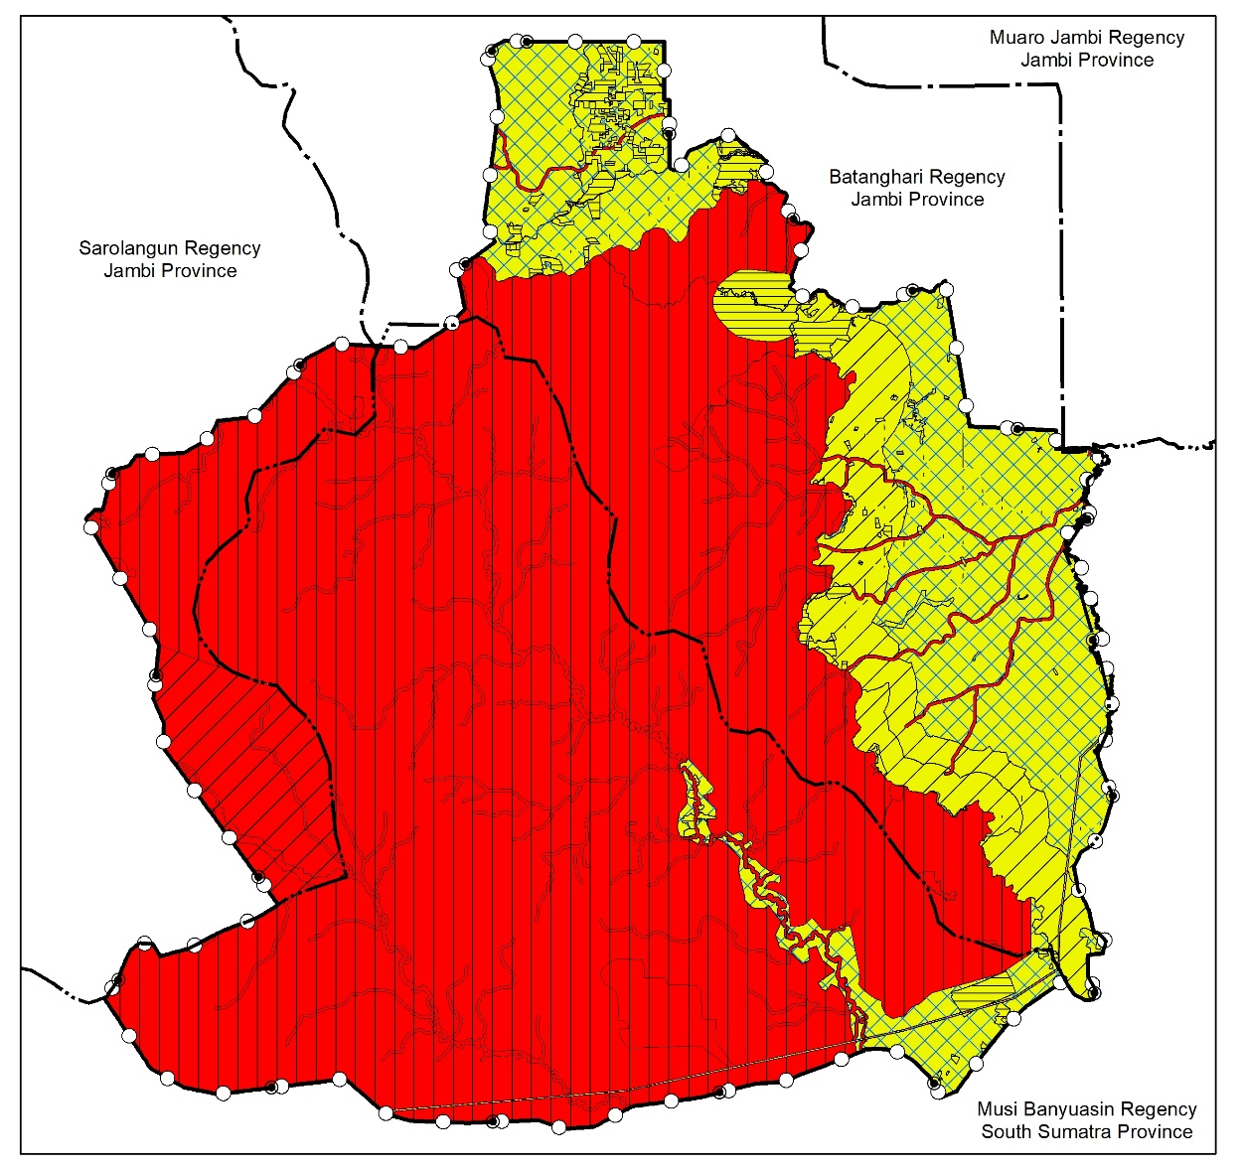
B.4. PPKH Area | Ha
Coal road | 208
SKK Migas Jindi Area | 3,88

A.2. Partnership Protection Areas | Ha
Environmental services; Collection of NTFPs | 3.685

A.1. Self-Managed Protection Areas | Ha
Environmental services | 69.107

B.1. Partnership Production Areas (existing) | Ha
Utilization of forest areas – agroforestry etc | 2.448

B.2. Production Area for Business Cooperation | Ha
Areas for cooperation development | 14.823
Existing cooperation area | 18

B.3. Self-managed production area | Ha
To be determined | 6.790
Existing utilization area | 32
Infrastructure | 3,8

Map 3. Indicative land allocation for land-use management

References, Glossary and Abbreviations
- Presidential Regulation 5/2025 on Forest Area Enforcement (Penertiban Kawasan Hutan)
- Government Regulation 23/2021 on the Implementation on the Implementation of Forestry
- Minister of Environment and Forestry Regulation 8/2021 on Forest Planning and the Preparation of Forest Management Plans as well as Forest Utilization in Protection and Production Forests
- Ministerial Regulation 9/2021 on Social Forestry Management
- Decree of Minister of Forestry – SK Menhut IUPHHK-RE No. SK.293/MENHUT-II/2007 on Granting of Ecosystem Restoration License (IUPHHK-RE) for PT REKI in South Sumatra Province
- Decree of Minister of Forestry – SK Menhut IUPHHK-RE No. SK.327/Menhut-II/2010 on Granting of Ecosystem Restoration License (IUPHHK-RE) for PT REKI in Jambi Province
- Decree of Minister of Environment & Forestry - SK MenLHK PBPH No.SK.1108/Menlhk/Setjen/HPL.0/11/2021 on Changing of IUPHHK-RE of PT REKI in South Sumatra Province into Forest Utilization Business Permit for Environmental Services (PBPH Jasa Lingkungan)
- Decree of Minister of Environment & Forestry - SK MenLHK PBPH No. SK.1196/MENLHK/Setjen/HPL.0/11/2021 on Changing of IUPHHK-RE of PT REKI in Jambi Province into Forest Utilization Business Permit for Environmental Services (PBPH Jasa Lingkungan)
- Circular Letter of the Minister of Environment and Forestry Number SE.6/MENLHK/SETJEN/PLA.4/12/2022 concerning the Approval of Forest Utilization Business Work Plans for Multi-Business Forestry Enterprises

Abbreviations and Glossary
AMDAL: Environmental Impact Assessment
Environmental Recovery: Pemulihan Lingkungan
ERCs: Ecosystem Restoration Concessions
Forest Area Enforcement: Penertiban Kawasan Hutan
Forest Area Enforcement Task Force: Satgas Penertiban Kawasan Hutan
IUPHHK-RE: Timber Forest Product Utilization Permits – Ecosystem Restoration
NbS: Nature-based Solutions
NTFP: Non-Timber Forest Product
PBPH Jasa Lingkungan: Forest Utilization Business Permits for Environmental Services
PT REKI: PT Restorasi Ekosistem Indonesia
Production forest area: Hutan Produksi
Protection Areas: Kawasan Lindung
RKU: Long-Term Management Plans
Working Area: Penataan Areal Kerja

https://mongabay.co.id/2025/02/01/perpres-penertiban-kawasan-hutan-solusi-atau-bencana-bagi-masa-depan-hutan-indonesia/
Under PP No. 23/2021 and PermenLHK No. 8/2021—the term used officially is pemulihan lingkungan, which is often translated as “environmental recovery.” This reflects a shift in nomenclature from the earlier use of “ecosystem restoration”, particularly under the Ecosystem Restoration Concession (ERC) framework.
Article 159(10)
Article 159(9)

